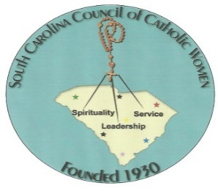**South Carolina Council of Catholic Women**

**2025 Catholic Woman of the Year Award**

**Guidelines**

1. Instructions and requirements stated within these guidelines **and** on the *2025 Catholic Women of the Year Nomination Form* must be followed; otherwise, entries will be disqualified.
2. A nominee must be an exemplary Catholic. She must also be an active member of her parish SCCCW affiliate, with both the affiliate and parish being in good standing with the South Carolina Council of Catholic Women.
3. Each affiliate president may nominate one individual (the affiliate’s Catholic Woman of the Year) to the deanery president for judging by a set deadline. The individual selected as the Deanery Catholic Woman of the Year will be nominated for the SCCCW Catholic Woman of the Year. The deanery president will submit a write-up on and a photo of the nominee, a letter of support from the nominee’s pastor and a SCCCW Catholic Woman of the Year Nomination Form (refer to the following page.)
4. Each nominee will be judged on her outstanding work performed.
5. The SCCCW President will choose at least three individuals from outside of SCCCW to judge the entries.
6. Only **one** nominee will be chosen to be the 2025 Catholic Woman of the Year.
7. A former nominee may be re-nominated; however, a new application must be submitted that includes a current nomination form, write-up, photo, and letter from her pastor.
8. Former winners of this honor are not eligible for re-nomination.
9. The winner shall be the guest of SCCCW at the 2025 SCCCW Convention. Her convention registration will be refunded by the SCCCW, and she will be honored at the Saturday banquet.

The SCCCW President must receive each deanery’s nominee for the SCCCW Catholic Woman of the Year Nominee **no later than** the SCCCW Pre-Convention Meeting, **February 8, 2025**!

Entries may be delivered in person or mailed. If an entry is mailed, it must be postmarked by and received no later than **February 8, 2025. M**ailed entries must be sent to the following address:

Jeannette Altenburg

1772 Bailey Ridge Drive

York, SC 29745

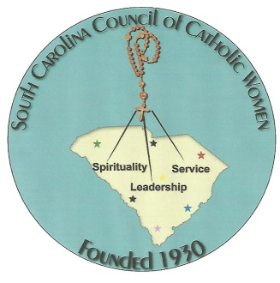**South Carolina Council of Catholic Women**

***2025 Catholic Woman of the Year Award***

***Nomination Form***

**Name: _____________________________________________ Age: _________**

**Address: __________________________________________________________**

**Parish: ____________________________________________________________**

**Name of Affiliated Organization: ______________________________________**

**Deanery: ___________________________________________________________**

***To be eligible, entry MUST contain ALL of the following items:***

* This *2025 Catholic Women of the Year Nomination Form*.
  + Form must be completed and signed/dated by person submitting entry.
* A photo of the nominee.
  + Photo must be **black & white** and 3” x 5” *or* 4” x 6” in size.
* A **one-page** letter of recommendation from nominee’s pastor.
* A nomination write-up.
  + Write-up must be typed using Times New Roman, 12-pt. font. Bold printing is NOT allowed.
  + Margins must be 1.00 inch (top and bottom) and 1.25 inches (left and right).
  + Pages must be double-spaced and one sided only.
  + Write-ups must be no longer than 3 pages and contain the following criteria:
    - 10 % Personal and family data
    - 50 % Church and affiliate activities
    - 40 % Civic and other activities

***Affiliate entries must meet respective Deanery President’s deadline.***

***Deanery nominees are due to SCCCW President by February 8, 2025.***

***___________________________________________________________ ______________***

**(Signature of Person Submitting Entry) (Date)**